Template for Evidence(s)
UI GreenMetric Questionnaire

University : ...
Country : ...
Web Address : …

[6] Education and Research (ED)
SAMPLE

[6.5] Total Research Funds Dedicated to Sustainability Research (in US Dollars)

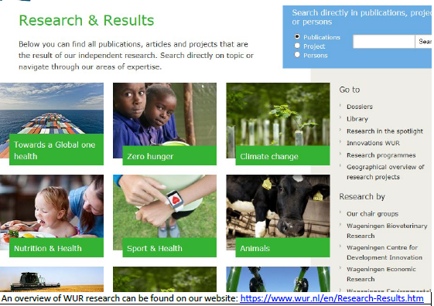
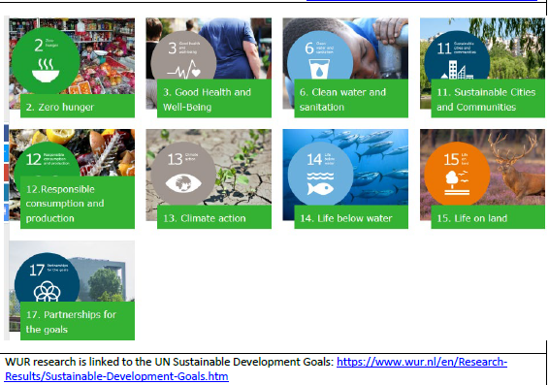
Example of Sustainability Research Fund (Wageningen University & Research, Netherlands)

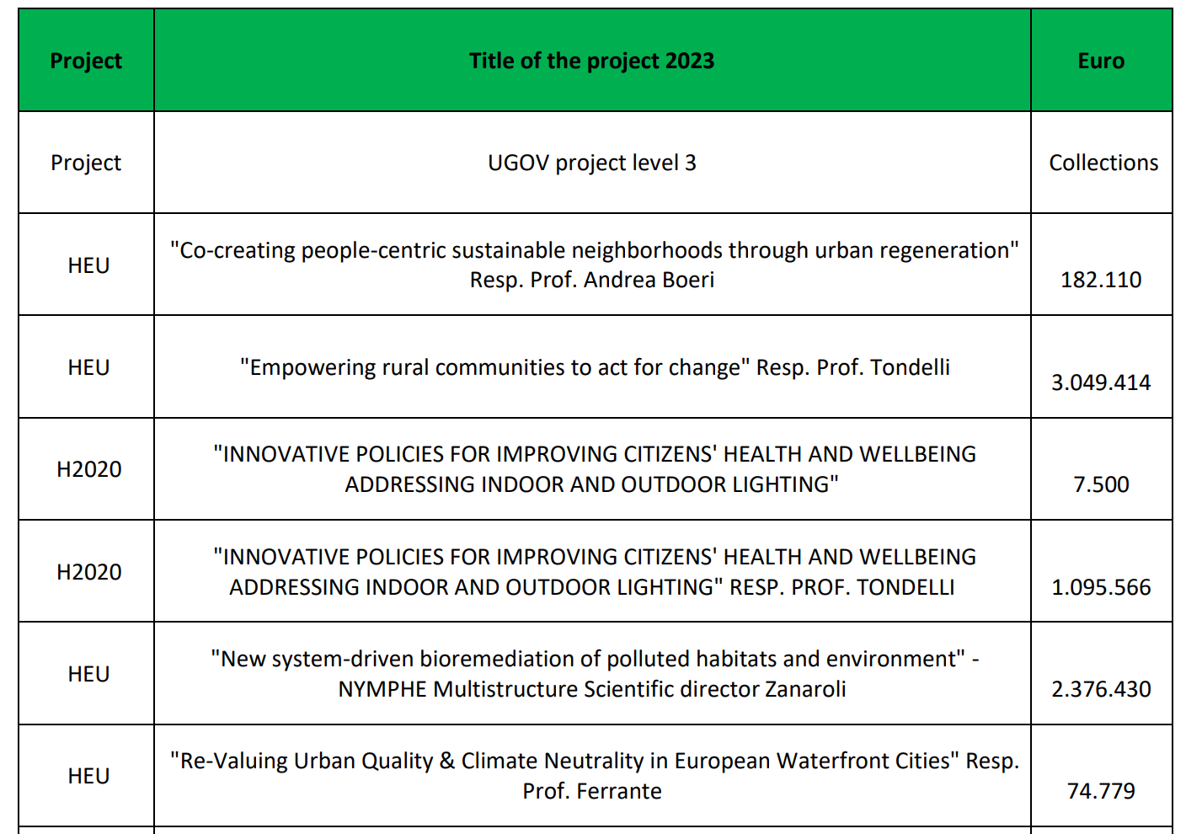
Description:
(Please describe total of sustainability research fund. The following is an example of the description. You can describe more related items if needed.)

Total research fund dedicated to sustainability research in 2022 = ……... US Dollars
Total research fund dedicated to sustainability research in 2023 = ……... US Dollars
Total research fund dedicated to sustainability research in 2024 = ……... US Dollars
The averaged annum last 3 years of research fund dedicated to sustainability research = ……... US Dollars

Additional evidence link (i.e., for videos, more images, or other files that are not included in this file):

